Boeing Autonomous
Operation and Assembly Manual
04/17/26

Introduction
This document outlines the features and functions of each component on the Boeing Autonomous Go-Kart. It includes but is not limited to assembly, disassembly, operation, maintenance, and necessary troubleshooting to ensure that the go-kart functions to its safest and most successful degree.

Safety Warnings
- Examine the entire go-kart for loose wires, damage, protrusions, or any other abnormalities
- Make sure that all subsystems are bolted down and secured during testing (even if they are not actively being tested)
- Make sure that the go-kart can fail safely (main-line brakes must be connected)
- When connecting a subsystem,
  - Test voltage of battery
  - Never cross 24v, 5v, and 3v
  - Never cross grounds
  - Always ensure you are grounded PROPERLY
  - Do not short-circuit the battery in any way.
- Always start the car in manual mode to avoid any unexpected movement.

Table of Contents
Introduction 1
Safety Warnings 1
1 Assembly 3
1.1 Brakes 3
1.1.1 Mechanical 3
1.1.2 Electrical 6
1.2 Steering 7
1.2.1 Mechanical 7
1.2.2 Electrical 12
1.3 Throttle 13
1.3.1 Mechanical 13
1.3.2 Electrical 16
2 Operation 16
2.1 Brakes 16
2.2 Steering 18
2.3 Throttle 19
3 Maintenance 20
3.1 Brakes 20
3.2 Steering 22
3.3 Throttle 22
4 Troubleshooting 23
4.1 Brakes 23
4.2 Steering 23
4.3 Throttle 24

Assembly

Brakes

Mechanical
- Required Tools
  - 6 Wrenches (Two; 14mm, Two; 13mm Two; 8mm)
  - Two Ratchet Wrenches (Bits; 5/16,11/16)
  - Screwdriver
  - Hex Allen key (2mm)
- Required Components
  - Mechanical Brake Caliper (2 pc)
  - Keyed Caliper Arm (made from steel, 1 pc)
  - Caliper Mounting Bracket (made from 1-1/2" steel bar, 1 pc)
  - 1" SS U-Bracket (2 pc)
  - 1/16" Rubber Packaging Sheets (4 cut to shape, 2in by 1in)
  - Limit Switch (1 pc)
  - Limit Switch Bracket (1 pc)
  - M5 x 16 Hex Bolt (2 pc)
  - M5 Hex Nut (2 pc)
  - M8 x 25 Hex Bolt (2 pc)
  - M8 Lock Nut (2 pc)
  - #8-32 x 1" Machine Screw (as needed)
  - #8-32 Nuts (as needed from 10 pack)
  - #8-32 1" Round Head Screws and Nuts (8 pack, as needed)
  - Brake Rotor (mounted on axle)
  - Brake Pads (with caliper)
  - Brake cable/rod and clevis (from pedal to keyed arm)
- Safety Precautions
  - Wear safety glasses
  - Work on a stable, level surface, if the kart is on jack stands, securely supported with chalk blocks to prevent rolling.
  - Ensure the brake rotor is clean and free of oil/grease.
  - Check all fasteners for proper torque and use lock nuts where specified.
  - Verify the limit switch cuts motor power when the brake is fully applied.
  - Test brake function in a safe, open area before full use.
  - Keep hands clear of moving parts during adjustment.
- Assembly Procedure
  - Mount brake rotor securely to axle/hub (if required)
  - Cut 4 1/16" rubber sheets to fit under each 1" SS U-bracket.
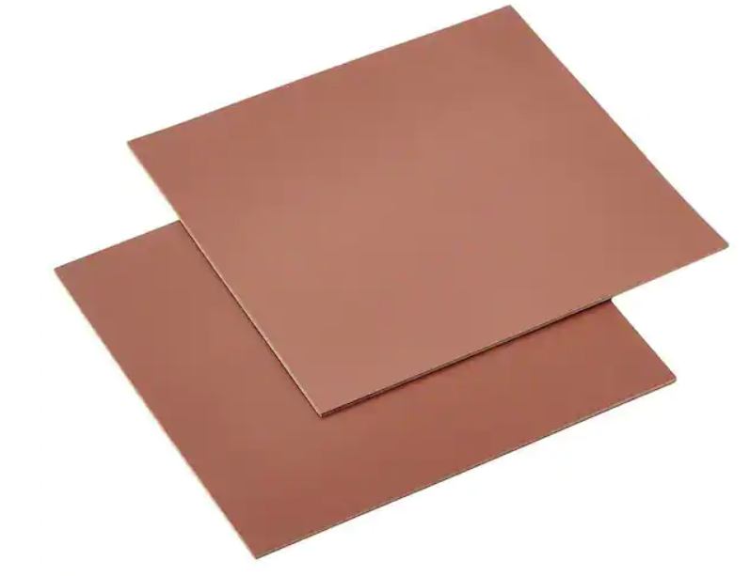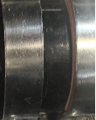
Figure 1: Rubber Sheets Figure 2: Fitted Rubber under U-Bracket
- Attach base plate loosely to frame using applicable screws and 1" SS U-brackets with rubber sheets between base plate and frame for vibration isolation (do not tighten U-clamps yet).
- Attach the caliper mounting bracket to the mechanical caliper using the screws supplied with the caliper.
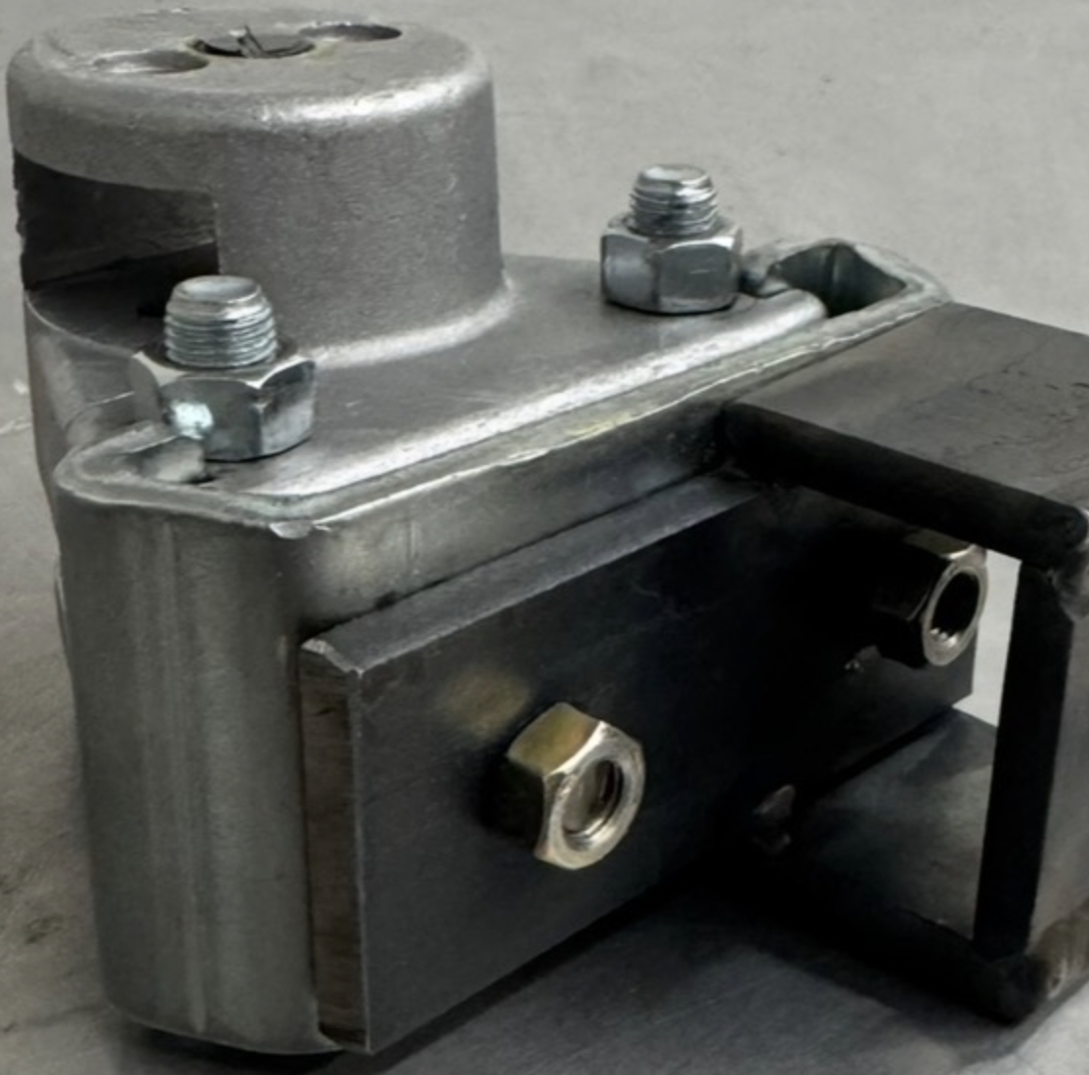
Figure 3: Caliper Mounting Bracket
- Slide brake pads onto caliper (one on each side of rotor). Position the fixed pad (on the right side when viewed from the back of the kart) snug against the rotor.
- Mount the caliper assembly loosely to the frame using the specified screws in the two holes of the caliper bracket (do not tighten, leave a slight sag for alignment).
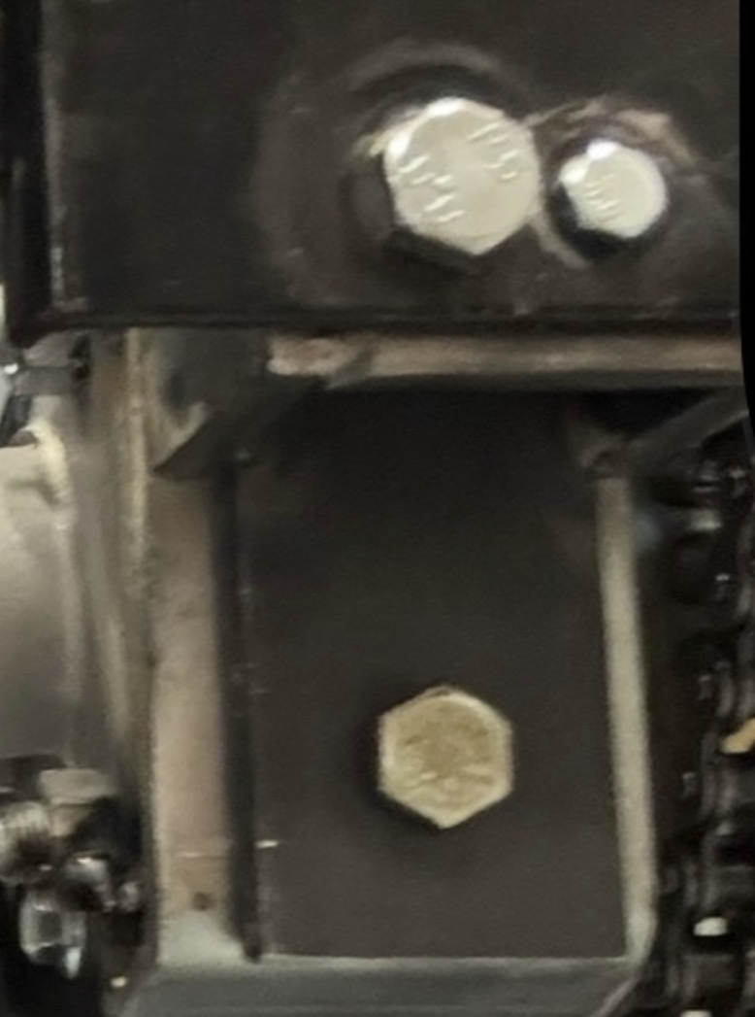
Figure 4: Caliper Bracket
- Slide the keyed caliper arm onto the motor tip at the axis of rotation (caliper pads) down 0.5 in from the smoothest surface, which faces toward the ball/push mechanism.
- Tighten the lead screw with a 2mm Allen key into the caliper arm and the flat side of the motor tip.
- Secure motor to base plate using #8-32 screws.
- Align the motor tip precisely with the caliper while adjusting the loose caliper bracket position.
- Once aligned, tighten the caliper mounting bracket fully to the frame.
- Go back and tighten all remaining screws:
  - Tighten the two mounting screws in the caliper bracket to the frame.
  - Tighten the 1" SS U-brackets on the base plate to the frame.
  - Tighten any loose screws on the motor to the base plate and caliper to the bracket.
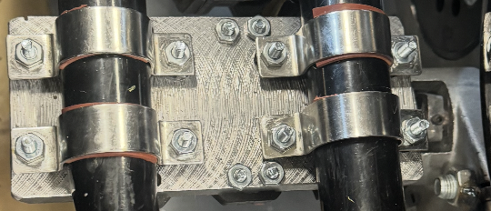
Figure 5: Base Plate Set Up
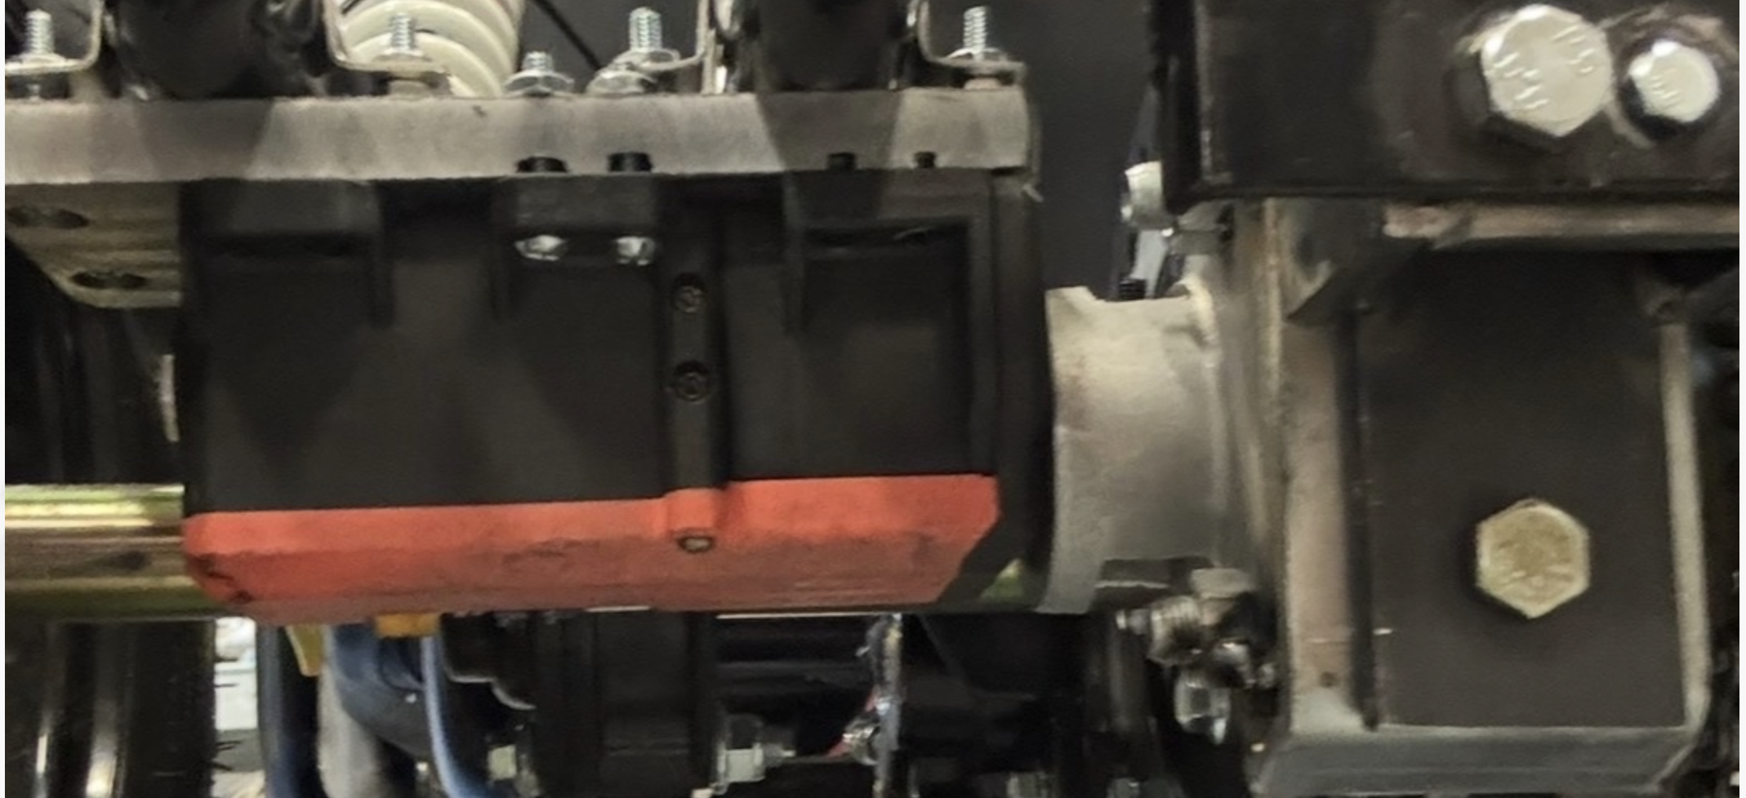
Figure 6: Side View of Motor-Caliper Mount
- Mount the limit switch by sliding onto the bars coming from the bracket, fasten the bracket using two screws, and position it by the brake pedal so it activates at full brake arm travel (the two holes the go-kart denotes the position of the bracket)
- Test pedal pull: ensure smooth actuation, full pad contact on both sides, and limit switch triggers.
- Disassembly Procedure
  - Loosen and remove the two screws mounting the limit switch bracket by the brake pedal.
  - Loosen all fasteners on the caliper mounting bracket to the frame (14mm and 8mm screws).
  - Loosen the 1" SS U-brackets on the base plate from the frame.
  - Loosen motor mounting screws (#8-32) from base plate.
  - Loosen lead screw with 2mm Allen key & remove from caliper arm & motor tip.
  - Slide the keyed caliper arm off the motor tip at the axis of rotation.
  - Remove caliper assembly from frame.
  - Detach caliper mounting bracket from mechanical caliper (remove supplied screws).
  - If needed, remove base plate from frame by fully loosening 1" SS U-brackets and screws.

Electrical
- Required Tools
  - Soldering iron
- Required Components
  - Raspberry Pi 5
  - Arduino Nano
  - 24 V battery
  - 5 V battery
  - Fuse Box
  - Signal wires
  - Power wires
- Safety Precautions
  - Connect to the 24 V battery last and disconnect first when testing
  - Ensure all wired connections are strong and safe
- Assembly Procedure
  - Solder all necessary connections
  - Upload programming to Arduino and Raspberry Pi
  - Connect RX and TX pins from Arduino to Pi
  - Connect three pin signal wire to servo motor, 5 V supply, and corresponding Arduino pin
  - Connect servo power wires to 20 A terminal in fuse box
  - Connect 24 V power supply to fuse box
- Disassembly Procedure
  - Disconnect 24 V power supply from fuse box
  - Carefully remove power from Servo Motor
    - Ensure yellow connector is in tact
  - Carefully remove signal wires from Servo Motor
    - Ensure white connector has all three wires attached
  - Disconnect remaining wires

Steering

Mechanical
- Required Tools
  - 5.5mm Wrench
  - 7mm Wrench (2)
  - 8mm Wrench (2)
  - 14mm Wrench
  - 2.5mm Allen Key
  - Phillips #1 (PH1) Screwdriver
  - Phillips #2 (PH2) Screwdriver
- Required Components

  - DOCYKE Servo Motor 550kg/cm
  - M3 x 30mm Bolt
  - M3 Lock Nut
  - M4 x 30mm Bolts (4)
  - M4 Lock Nuts (4)
  - M5 x 30mm Bolts (10)
  - M5 Lock Nuts (10)
  - M6 x 30mm Bolts (3)
  - M6 x 15mm Bolts (3)
  - M6 x Lock Nuts (6)
  - 5mm Set Screws (3)
  - #8-32 x 2-1/2in Screws (8)
  - #8-32 x 2-1/2in Bolts (8)
  - 1” Steel U clamps (4)
  - Motor Mount Base
  - Motor Mount Wedges (2)
  - Rubber Pads (4)
  - Gear
  - Pinion
  - Encoder Top Mount
  - Encoder Bottom Mount
  - Rack Cover
  - Rack Cover Clamps (4)
  - Gearbox Front Cover
  - Gearbox Back Cover
  - Encoder Mount Subassembly
  - Encoder Bottom Mount
  - 1” Rubber Lined Clamp
  - Loctite Blue Thread locker

- Safety Precautions
  - Inspect all components are free of defects (cracks, deformation, stripped threads).
  - Do not load the system until the thread locker has cured for at least 24 hours.
  - Keep hands clear of pinch points during alignment of gear and pinion.
  - Ensure that all components and fasteners are securely attached before operation.
  - Disconnect all electrical components before disassembly.
- Assembly Procedure
  - As seen in Fig. 7, assemble the motor subassembly as shown below. Secure the M4 and M5 Bolts with 7mm and 8mm Wrenches.
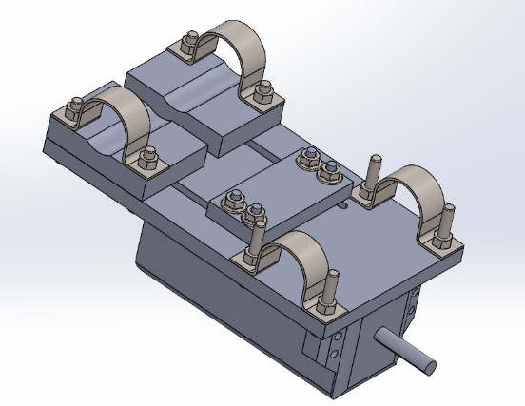
Figure 7: Motor Mount Subassembly
  - Attach the motor assembly to the go kart rack at the position shown in Fig. 7.
  - Install the motor mount subassembly using four U-clamps:
    - Place one rubber pad between each clamp and the rack bar
    - Position clamps over the mount and rack bars
    - Tighten clamps finger-tight only to allow adjustment
      - The motor mount must remain adjustable for proper gear meshing.
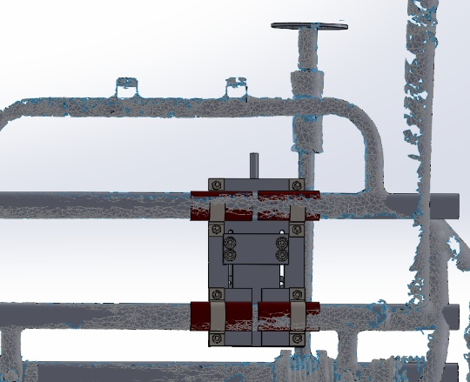
Figure 8: Motor Mount Subassembly Position
  - Loosen the steering column to allow axial movement without full removal as shown in Fig. 9.
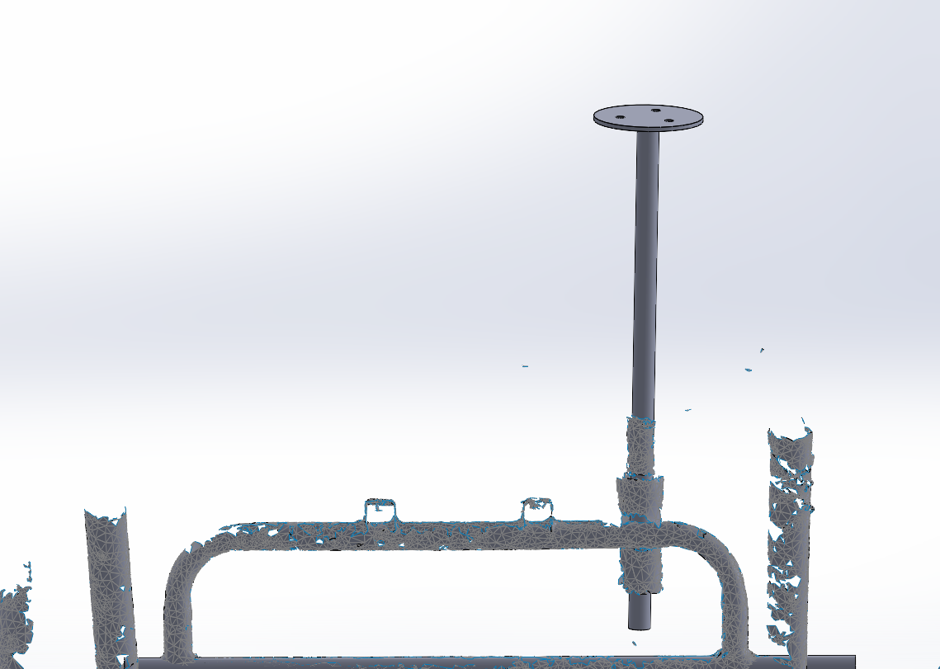
Figure 9: Steering Column Detachment
  - Slide the front gearbox cover onto the steering column. Then slide the gear onto the steering column.
  - Slide the rear gearbox cover into position and fit the motor mount subassembly key through the square opening.
  - Align the gear with the machined flat (shaven portion) on the shaft.
  - Apply Loctite Blue to two set screws.
  - Tighten the set screws to secure the gear to the shaft using the 2.5mm Allen Key.
  - Attach the pinion to the motor key by applying Loctite blue to the pinion’s set screw. Use the 2.5mm Allen Key to fasten the set screw. Ensure the gears can mesh when the subassembly is pushed towards the gear.
  - Reinstall and secure the steering column to the vehicle. Important: Allow Loctite to cure for 24 hours before operation.
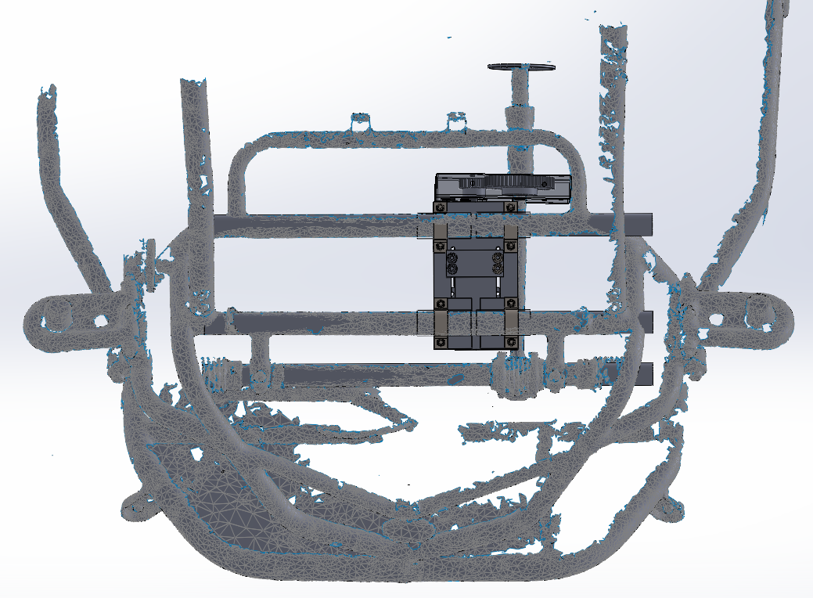
Figure 10: Steering Assembly with Gear, Pinion, and Gearbox Covers Installed
  - Insert the top encoder mount attachment by aligning the three holes and tightening the bolts with M6 nuts using the 14mm wrench to the steering column as seen in Fig. 11.
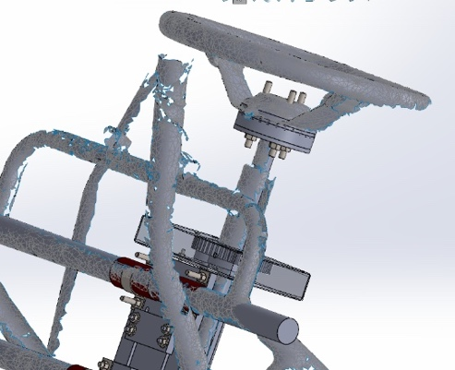
Figure 11: Top Encoder Mount Installation
  - Install the bottom encoder mount attachment by aligning the three holes to the steering rack boot/dust cover and securing the screws with a Phillips #1 (PH1) Screwdriver.
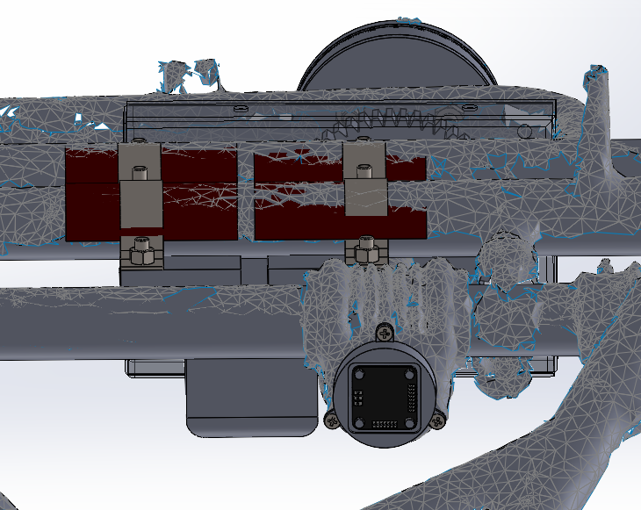
Figure 12: Bottom Encoder Mount Installation
  - Adjust the motor mount subassembly’s position until the pinion aligns and meshes with the fixed gear. Afterwards, fasten the motor mount subassembly using two 8mm wrenches until hand tight to fix into place.
  - Use the M3 bolt to secure the motor and back gearbox cover together as shown in the figure below. Tighten the M3 bolt and nut securely using the 5.5mm wrench.
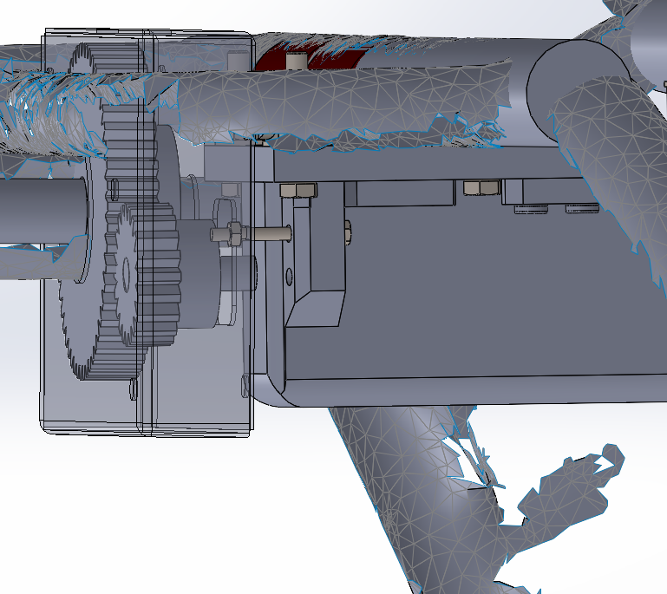
Figure 13: Fastening Motor to Gearbox Rear Cover
  - Secure the gearbox covers together with the 1” Rubber Lined Clamp and three M5 bolts and nuts. Secure with the 8mm wrenches.
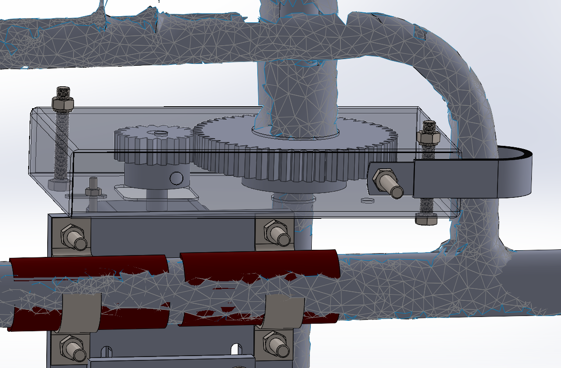
Figure 14: Fully Assembled Gearbox with Covers Secured
  - Attach the rack cover by aligning the rack clamps with the holes made in the rack cover. Fasten the cover by screwing in the eight #8-32 screws and bolts with the Phillips #2 (PH2) Screwdriver. The full steering assembly is depicted in Fig. 15.
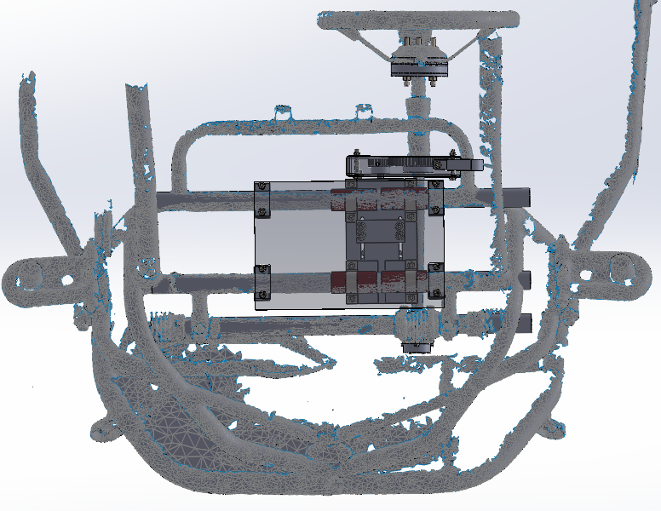
Figure 15: Top Level Steering Assembly
  - Lastly, conduct a final inspection. Verify all fasteners are tight and there is no interference or misalignment.
- Disassembly Procedure
- Disassemble the rack cover by removing the screws and bolts.
- Remove both the top and bottom encoder mounts by unbolting and unscrewing the mounts from the vehicle.
- Remove the 1” Rubber lined clamp along with all three M5 bolts and nuts to separate the gearbox covers.
- Remove the M3 bolt and nut that secured the motor to the gearbox back cover.
- Detach the motor mount subassembly from the vehicle.
- Disassemble the motor mount assembly. Break the Loctite blue bond to detach the pinion.
- Loosen the steering column to allow axial movement without full removal.
- Remove the gearbox back cover.
- Remove the gear after breaking the Loctite blue bond.
- Slide off the gearbox front piece.

Electrical
- Required Tools
  - Soldering iron
  - Solder wire
- Required Components
  - Raspberry Pi 5
  - Arduino Nano
  - Magnetic encoder x2
    - Signal wires
  - 24 V battery
  - Fuse Box
  - Servo motor signal wires
  - Servo motor power wires
  - 5 V battery
- Safety Precautions
  - Gear box is secured
  - Wires properly connected
- Assembly Procedure
  - Upload programming to Arduino and Raspberry Pi
  - Connect Servo Motor power wires to 20 A terminal in fuse box
  - Connect signal wires to 5 V power supply, encoders and servo motor, and corresponding Arduino pins
  - Ensure Arduino TX and RX pins connect to Raspberry Pi
  - Connect 24 V battery to fuse box
- Disassembly Procedure
  - Disconnect 24 V battery
  - Carefully remove power from Servo Motor
    - Ensure yellow connector is intact
  - Carefully remove signal wires from Servo Motor
    - Ensure white connector has all three wires attached
  - Disconnect remaining wires

Throttle

Mechanical
- Required Tools
  - Wrench 9 mm
  - Wrench 8 mm
  - Allen Wrench Kit
- Required Components
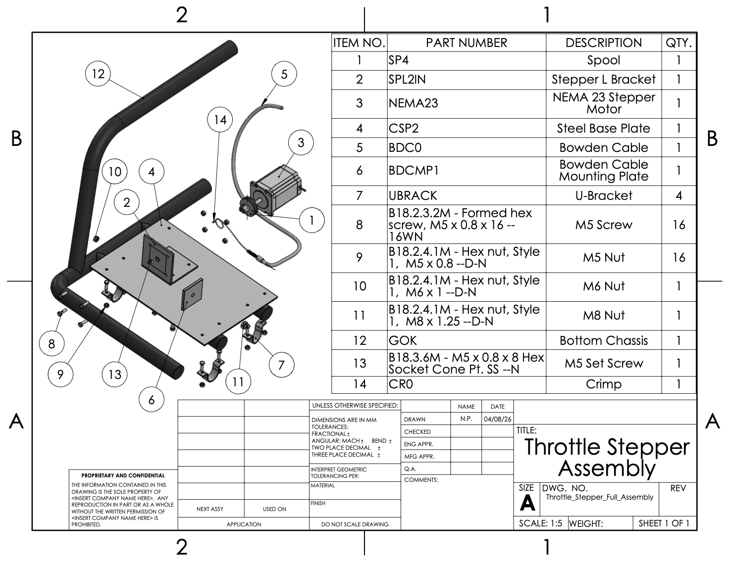
Figure 16: Throttle Stepper Assembly
  - NEMA 23 Stepper Motor
  - 24” Throttle Cable
  - M5 Lock Nuts
  - M5 x 20 mm Hex Bolt
  - Set screw
  - Electric Throttle Pedal
  - U clamps
  - Crimp
  - Stepper Motor Mounting Bracket
    - Material: 3/16” Steel flat bar
    - Manufacturing: Bandsaw/Drill/Weld
    - Dimensions: 3” x 3” plates
    - Function: To hold the steeper motor up
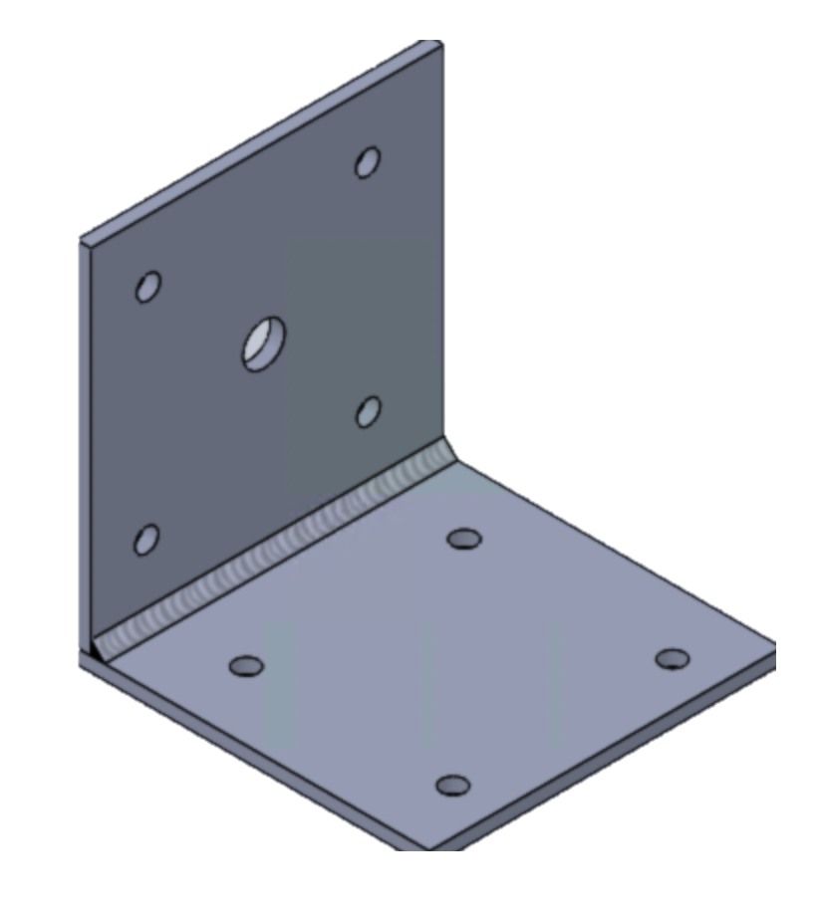
Figure 17: Welded L-Bracket
  - Bowden Cable Bracket
    - Material: 3/16” Steel flat bar
    - Manufacturing: Bandsaw/Drill/Weld
    - Dimensions: 2” x 2”
    - Function: To hold the Bowden cable in place and line it up with the spool on the stepper motor.
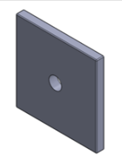
Figure 18: Welded Bowden Cable Mount
  - Throttle Base Plate
    - Material: 14 Gauge Steel
    - Manufacturing: Bandsaw/Drill
    - Dimensions: 8” x 12”
    - Function: To mount the stepper motor and Bowden cable bracket.
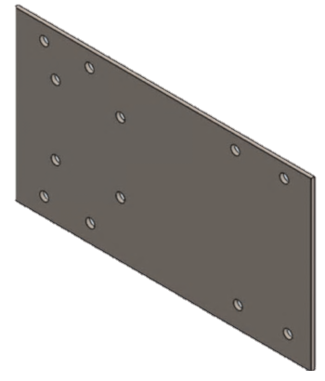
Figure 19: Throttle Base Plate
  - Stepper Spool
    - Material: Aluminum Bar
    - Manufacturing: CNC/Weld
    - Dimensions: d = 1.5”
    - Function:
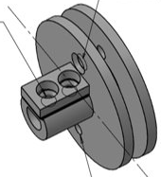
Figure 20: Throttle Spool
- Safety Precautions
  - Disconnect the battery before wiring
  - Do not cross the positive and negative connections of the 24 V battery
  - Ensure the 3 V, 5 V, and 24 V power does not get crossed
- Assembly Procedure
- Align the stepper motor with the mount and secure it using M5 bolts and lock nuts. Tighten fully with a wrench to ensure it is firmly in place.
- Position the Bowden cable bracket so it is perpendicular to the stepper motor. Weld it securely to the baseplate and allow it to cool.
- Place the baseplate onto the back, right end of the go-kart chassis and secure it using U-clamps (with pre-cut rubber inserts), M5 bolts, and lock nuts. Tighten to prevent movement.
- Remove the nut from the Bowden cable and feed the cable through the bracket. Reattach it and tighten the nut to secure the cable housing.
- Feed the throttle cable through the spool hole, pill it taut, and secure it with a crimp and solder.
- Slide the spool onto the stepper motor shaft and tighten the set screw so it is firmly secured.
- Attach the free end of the cable to the throttle lever and adjust tension so the throttle closes fully at rest and opens smoothly.
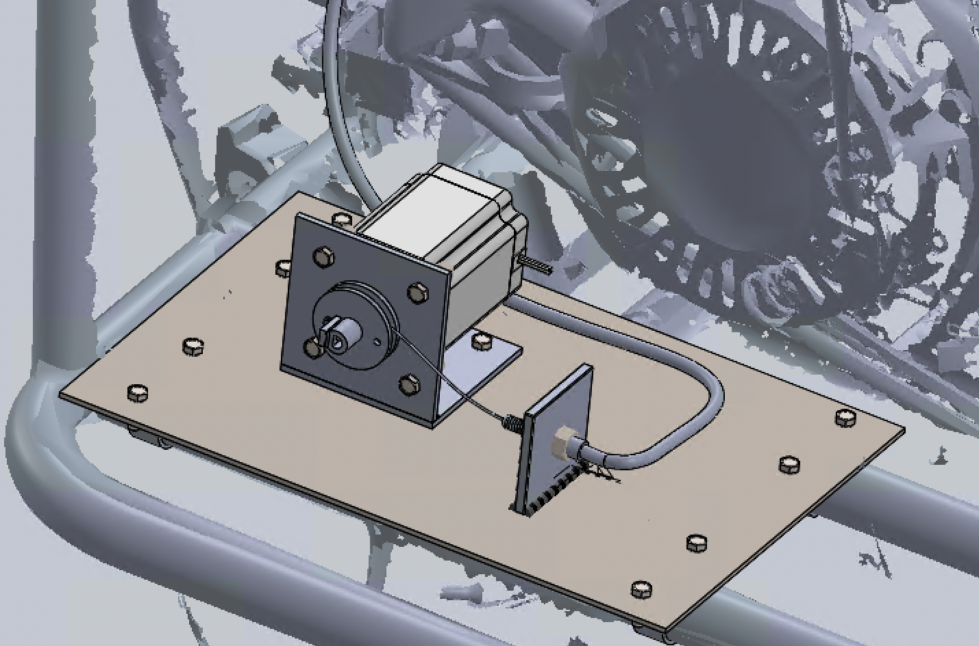
Figure 21: Throttle Stepper Motor Mount
- Disassembly Procedure
- Disconnect the throttle cable from the throttle lever
- Loosen the set screw and remove the spool from the stepper motor shaft
- Remove or cut the crimp and pull the cable out of the spool
- Loosen the nut and remove the Bowden cable from the bracket
- Remove the M5 bolts and U-clamps, then take the baseplate off the chassis
- Remove the bolts securing the stepper motor and take it off the mount.

Electrical
- Required Tools
  - Soldering Iron
  - Electrical tape
  - Wire strippers
- Required Components
  - Raspberry Pi 5
  - Arduino Nano
  - Motor Driver
  - Hall effect sensors x2
  - 24 V battery
  - 5 V battery
  - Fuse box
  - Signal wires
  - Power wires
- Safety Precautions
  - Connect to the 24 V battery last and disconnect first when testing
  - Ensure all wired connections are strong and safe
- Assembly Procedure
- Upload programming to Raspberry Pi and Arduino Nano
- Mount Hall Effect Sensors
- Connect corresponding 5V, ground, and signal Hall wires to respective terminals in electric box
- Connect 5V to respective motor driver pins
- Connect Arduino Digital pins to Stepper pins
- Connect RX and TX Arduino to Raspberry Pi
- Connect motor driver to 5 A terminal in fuse box
- Connect 24 V battery to fuse box
- Disassembly Procedure
- Disconnect 24 V battery from fuse box
- Disconnect 5 V battery
- Disconnect motor driver from 5 A terminal
- Disconnect Arduino signal pins from Pi
- Remove remaining wires

Mechanical Operation

Brakes
- Pre-Operation Checklist
  - Check that the 8-32 screws and M8 hex bolts are not missing and are tight
  - Check that the brake puck is in the off position
  - Check that the limit switch/ limit switch mount is not broken or missing underneath the brake pedal
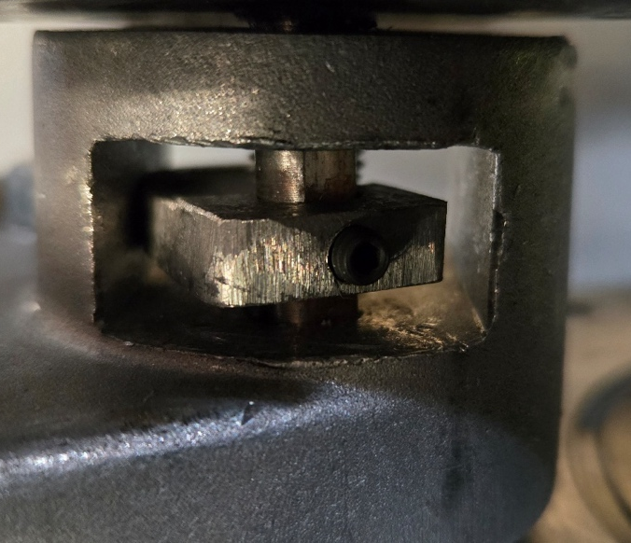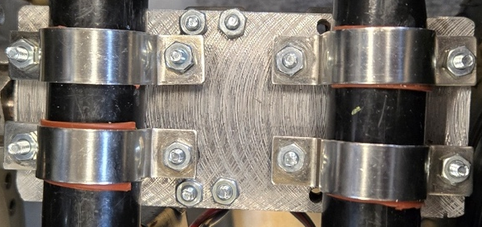
Figure 23: Brake Puck in Off Position Figure 24: Twelve 8-32 Screws
- Startup Procedure
  - Start the kart according to the manufacturer's instructions
  - Ensure the rider is wearing a helmet and seatbelt
  - If the user wishes to engage autonomous mode, then open the associated program provided with the kart
- Normal Operation
  - To engage the brake, manually press on the brake pedal.
- Shutdown Procedure
  - To shut down the system, press and hold the brake pedal and flip the emergency switch. The emergency switch will need to be flipped again to restart operation, so click it back on once the engine is killed.
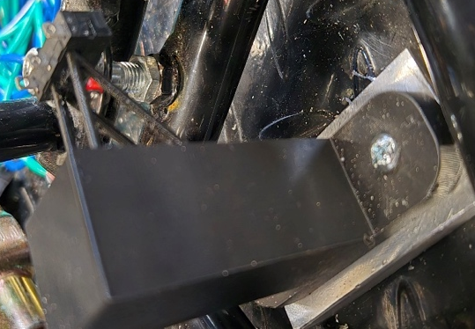
Figure 25: Limit Switch Mount Underneath Brake Pedal
- Emergency Procedure
  - In an emergency, press on the brake pedal to slow the kart abruptly to a stop
  - If the autonomous brake is stuck in the on position, then press the brake pedal
  - If the autonomous brake is still stuck in the on position, then cease operation with the emergency turn off. Then use regular pliers to unstick the puck. Try the startup procedure once more. If the puck still does not move, then see an associated Boeing Autonomous mechanic.
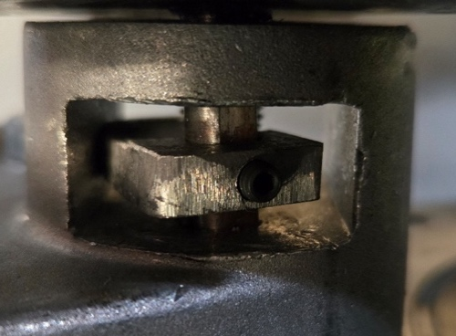
Figure 26: Brake Puck in the On Position

Steering
- Pre-Operation Checklist
  - Battery charged
  - Wiring secure
  - Sensors calibrated
  - Area is clear
  - Servo motor calibrated
- Startup Procedure
  - Start the kart according to the manufacturer's instructions, with the motor turned on
  - Ensure the rider is wearing a helmet
  - Ensure the kart is in manual mode
  - Flip the switch to autonomous when ready
- Normal Operation
  - While in manual mode, operate the steering wheel the same as any vehicle
- Shutdown Procedure
  - Flip switch to manual mode
  - Maintain control of steering wheel
- Emergency Procedure
  - Activation of the Emergency Stop button will halt the system
  - Maintain control of the wheel

Throttle
- Pre-Operation Checklist
  - Make sure 24 V battery is charged
  - Check if all wired connections are strong
  - Check if connection to 24 V battery is safe
- Startup Procedure
- Ensure choke and gas switch are on
- Make sure the kart is in neutral
- Pull starting cable
- Turn choke switch off once started
- Put kart in forward gear
- Normal Operation
  - Kart should be put into autonomous mode unless manual mode is desired
  - Lidar and navigation controls should be reading the environment and thinking accordingly to what the kart sees
  - The kart should apply throttle and brakes when needed, and steer in a fashion that will not result in a collision or injury
- Shutdown Procedure
- Hit the kill switch to turn off the kart
- Disconnect from the 24 V battery
- Power off electrical box
- Emergency Procedures
  - The emergency stop method is a master kill switch that disconnects the 24 V battery from the electrical box
  - If the mechanical set up fails in any way, disengage the throttle using the kill switch and shut off any other interacting electrical components.

Maintenance

Brakes
- Maintenance Schedule
Component | Action | Frequency
Brake Pads | Inspect for wear, cracks, or glazing; replace if thickness < 2mm | Every 10 operating hours or monthly
Brake Rotor | Inspect for scoring, warping, or rust; clean or replace if needed | Every 20 operating hours
Keyed Caliper Arm | Inspect for wear on the keyed slot or arm; replace if loose or damaged | Every 20 operating hours
Lead Screw & Motor Tip | Check tightness; clean and re-tighten with a 2mm Allen key | Every 10 operating hours
Limit Switch & Bracket | Test activation; inspect wiring and mounting screws | Every 10 operating hours
All Fasteners (M5, M8, #8-32, U-brackets) | Check torque and security; re-tighten or replace if loose | Every 5 operating hours or after every ride
Rubber Isolation Sheets | Inspect for compression or tearing; replace if damaged | Every 20 operating hours
Complete Brake System | Full visual inspection + test pedal pull and limit switch operation | Before every use

- Inspection Procedures
  - Brake Pads: Check thickness and condition on both sides.
    - Normal: Even wear, thickness > 3mm, no cracks or glazing.
    - Problem: Thickness ≤ 2mm, deep grooves, cracking, or shiny glazed surface.
  - Brake Rotor: Spin the rotor by hand and visually inspect the surface.
    - Normal: Smooth, clean surface with light, even wear pattern.
    - Problem: Deep scoring, grooves, blue discoloration (overheating), warping, or heavy rust.
  - Keyed Caliper Arm & Motor Tip: Check fit and wear at the keyed connection.
    - Normal: Tight fit with no visible play or slop when moving the arm.
    - Problem: Worn key slot, rounded edges, or excessive movement at the motor tip.
  - Lead Screw: Inspect threads and tightness.
    - Normal: Securely tightened, clean threads, no visible wear.
    - Problem: Loose, stripped threads, or visible wear on flat contact surface.
  - Limit Switch & Bracket: Inspect mounting and test operation.
    - Normal: Firmly mounted with no movement, activates cleanly at full brake travel.
    - Problem: Loose bracket, frayed wiring, exposed conductors, or inconsistent activation.
  - All Fasteners & Rubber Sheets: Check torque on M5, M8, #8-32 screws, U-brackets, and condition of rubber pads.
    - Normal: All bolts tight, rubber sheets intact and properly compressed.
    - Problem: Loose or missing fasteners, crushed/torn rubber sheets, or striped threads.
  - Overall System Test: Pull the brake pedal fully and observe.
    - Normal: Smooth actuation, strong stopping power, immediate return, limit switch triggers motor cutoff.
    - Problem: Spongy feel, dragging when released, delayed limit switch, or grinding noises.
- Calibration Procedures
- Loosen the two mounting screws on the caliper bracket to allow slight movement.
- Slide the keyed caliper arm onto the motor tip at the axis of rotation (0.5 in down the shaft from the smooth surface, which is facing toward the push mechanism (ball)).
- Tighten the lead screw using a 2mm Allen key into the caliper arm and the flat side of the motor tip.
- Position the limit switch bracket by the brake pedal so the switch activates exactly at full brake arm travel.
- Secure the limit switch bracket using the two screws.
- Tighten the caliper mounting bracket fully to the frame using the 14mm lock nut and 8mm screw.
- Tighten the 1" SS U-brackets on the base plate to the frame.
- Cycle the brake pedal 10 times limit switch activation.
- Perform a low-speed test run in a safe area: verify immediate strong stopping, no dragging when released, and that the limit switch cuts motor power at full brake application.
- Final torque check on all fasteners and re-test before normal operation.

Steering
- Maintenance Schedule
Component | Action | Frequency
Gear System (Gear, pinion, box) | Inspect for visual wear and tear, replace if chipped or cracked | Every 10 operating hours or monthly
Encoder Mount (Top, Bottom) | Inspect for visual wear and tear, if wore or warped replace | Before every ride
All Fasteners (M3, M5, M6, M8, #8-32, U-brackets) | Check torque and security; re-tighten or replace if loose | Before every ride
Rubber Isolation Sheets | Inspect for compression or tearing; replace if damaged | Every 20 operating hours
Complete Steering System | Full visual inspection + test steering wheel operation | Before every use

- Inspection Procedures
- Gear System: Check condition of gear, pin and box.
  - Normal: Clear of marks and dents, gears are meshed, and gears are secured.
  - Problem: Chip, cracks, dents, and unalignment of gears
- Encoder Mount: Check condition of encoder mounts and encoders
  - Normal: Clear of discoloration, smooth movement of wheel, and fully secured.
  - Problem: Signs of discoloration, and instability in wheel
  - All Fasteners & Rubber Sheets: Check torque on M3, M5, M6, M8, #8-32 screws, U-brackets, and condition of rubber pads.
  - Normal: All bolts tight, rubber sheets intact and properly compressed.
  - Problem: Loose or missing fasteners, crushed/torn rubber sheets, or striped threads.
  - Overall System Test: Pull the wheel fully to one side and observe.
    - Normal: Smooth actuation, and motor alignment.
    - Problem: Grinding noises, skipping in steering, and lack of response.
- Calibration Procedures
- Initialize system
    - Check if motor is operating within the correct bounds
    - Check if encoder is functioning properly
- Run calibration program
    - Ensure the correct code is controlling the steering subsystem
- Verify output matched expected response

Throttle
- Maintenance Schedule
Component | Action | Frequency
Stepper Motor | Inspect for proper operation, check wiring connections, no overheating or unusual noise | Weekly
Spool | Check for wear, ensure set screw is tight, verify smooth rotation | Weekly
Throttle Cable/Bowden Cable | Inspect for fraying, kinks, and smooth movement | Before each use
Pedal | Check for smooth movement and proper return to rest position | Before each use
Fasteners | Check all bolts, nuts, and clamps for tightness | Before each use

- Inspection Procedures
  - Spool: Check condition of spool and set screw
    - Normal: No cracks or wear, rotates smoothly, securely attached to motor shaft
    - Problem: Cracks, wear, wobbling, or loose/missing set screw
  - Throttle cable: Check condition of inner cable and outer housing
    - Normal: Cable moves smoothly, no fraying or kinks, securely mounted in bracket
    - Problem: Frayed strands, kinks, sticking, or loosening mounting
  - Pedal: Check condition and movement of pedal assembly
    - Normal: Smooth motion, returns to rest position, no excessive play
    - Problem: Sticking, delayed return, or loose/unstable pedal
  - Fasteners: Check torque on M5 bolts, lock nuts, and U-clamps
    - Normal: All fasteners tight and secure, no movement between components
    - Problem: Loose or missing fasteners, stripped threads, or shifting components
- Calibration Procedures
- Initialize system
    - Check if motor is operating within the correct bounds
    - Adjust motor position if needed
- Run calibration program
    - Ensure the correct code is controlling the throttle subsystem
- Verify output matched expected response

Troubleshooting

Brakes
Problem | Possible Causes | Solution
Brake weak or not engaging | Lead screw loose or slipped, Caliper arm not seated correctly, Motor not driving caliper | Tighten the lead screw with a 2 mm Allen key into the motor tip flat  Re-seat the arm and secure with M5 hardware  Check wiring and test the motor
Brake dragging / rotor overheating | Pads not retracting. Misalignment in the bracket or base plate. The fixed pad is too tight | Loosen bracket, align motor tip to caliper, re-tighten. Adjust pads to lightly clear the rotor. Check fixed pad position
The limit switch is not stopping the motor | Misaligned or loose switch bracket, faulty switch or wiring, arm not reaching the switch | Reposition the switch to trigger at full travel. Tighten the bracket. Inspect wiring / replace switch
Excessive play or rattling | Loose fasteners. Worn rubber isolation sheets. Worn arm or motor tip | Tighten all hardware (use thread locker). Replace rubber sheets. Replace worn parts
Spongy or inconsistent pedal | Loose or stripped lead screw. Poor alignment. Worn or glazed pads | Re-tighten or replace the lead screw  Re-align assembly  Replace pads if under 2-3 mm
Motor runs, but no braking force | Lead screw not engaged. Arm installed incorrectly. Caliper piston binding | Reinstall and tighten correctly. Ensure proper arm seating. Clean and lightly lubricate the caliper
The brake locks too easily | Pads are too aggressive. The limit switch triggers too late | Reduce initial pad contact. Adjust the switch for earlier activation
Vibration or noise | Loose mounting hardware. Damaged rubber sheets. Misalignment | Tighten brackets and U-mounts. Replace rubber sheets. Re-align components

Steering
Problem | Possible Cause | Solution
Motor not responding | Loose connection. Wire damage. | Check connection port for damage and replace damaged pieces.
Steering response | Encoder magnet misalignment. | Disassemble and re-align magnet.
Gears skipping | Loose set screw. Miss aligned or unmeshed gears. | Reattach set screw with Loctite glue. Re-mesh gears.
Excessive play or rattling wheel | Loose fasteners. Worn rubber isolation sheets. Worn arm or motor tip. | Tighten all hardware with thread locker. Replace rubber sheets. Replace worn parts.
Vibration or noise | Loose mounting hardware. Damaged rubber sheets. Misalignment. | Tighten brackets and U-mounts. Replace rubber sheets. Re-align components.

Throttle
Problem | Possible Cause | Solution
Throttle not responding (no movement when input is given) | Stepper motor not powered, loose wiring, incorrect code, spool slipping, or broken/disconnected cable | Check power and wiring connections, verify control code is running, tighten set screw on spool. Reconnect or replace cable
Delayed response (slow or lagging throttle movement) | Slack in Bowden cable, friction in Bowden cable, weak motor signal, or misalignment | Adjust cable tension. Check motor input signal, realign components
Throttle lever not returning to idle | Spring detached or broken, cable too tight, friction in cable, obstruction at linkage | Reattach or replace spring, adjust cable tension, lubricate cable, remove obstruction
Excessive vibration or rattling | Loose nuts or bolts, misalignment, or worn components | Tighten all fasteners, realign components, replace worn parts if needed

Electrical
Problem | Possible Cause | Solution
Subsystem not responding | Component became damaged/blown out | Find and replace the problematic component
Motor not getting power/signal | A wire became disconnected/damaged | Find and replace the problematic wire
Kart will not enter autonomous mode | Kart thinks there is a problem and therefore wants manual mode for safety | Examine and correct the error to allow autonomous mode to function
Components are not receiving power | Dead battery or broken connection | Charge battery or examine all connections with multimeter to ensure flow of power

